**Cyber Security Essentials by LetsUpgrade**

Assignment -2

1. Creating payload for windows machine

Using msvenom , Created payload for windows machine with LHOST as below shown figure:-

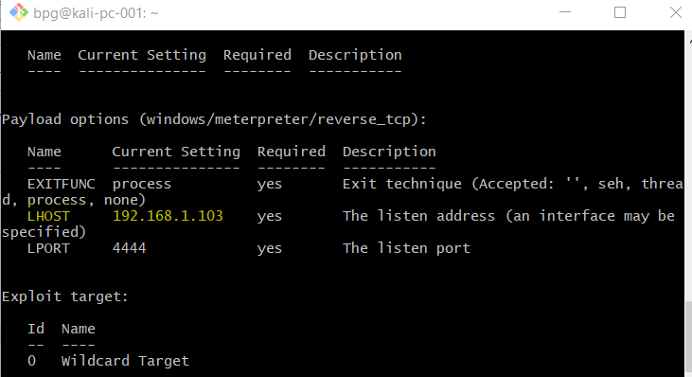

Below is the screenshot of game and text file has been transferred to the Victims machine.

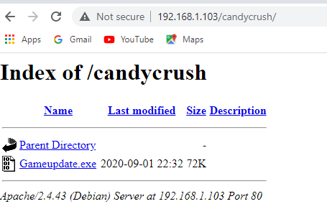

Exploiting windows machine:- Using command exploit -j -z

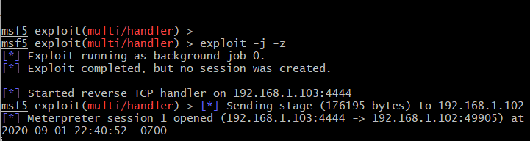

Below is the screenshot for the sessions:- using sessions -i 1

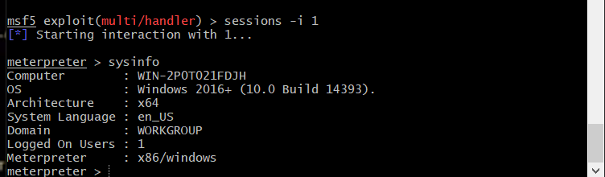

Transferring and receiving files from victims machine :-



